# LaserPi Pi Zero W Installation Instructions

1. Component Requirements:
   1. Raspberry Pi Zero W
      1. SD Card, Minimum 8GB
      2. USB Power for Pi Zero
   2. Adafruit Perma-Proto Pi Hat
   3. 1W Resistors, 330 x2, 10k, 220 Ohms
   4. Light Emitting Diodes. Multiple colors.
   5. Capacitor, 0.1pF
   6. Transistor, 2N3904/2N3906
   7. Temporary Push Button, (Any button suitable for triggers.)
   8. Infrared Light Emitting Diode
   9. Infrared Receiver, 37.9KHz Compatible
   10. Solder the components based on the schematic:

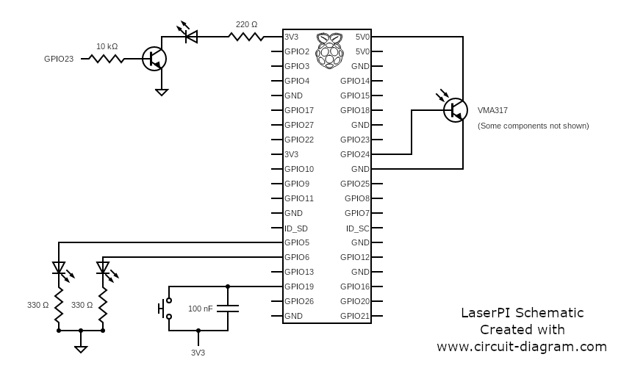

1. Network Requirements:
   1. The Pi Zeros need to have wireless access at all times. The individual Pi Zeros used as guns do not need to be connected to the same network. Any hotspot will work including a cell phone hotspot.
2. Raspberry Pi Zero W Installation
   1. Download and install the Raspbian OS from <https://www.raspberrypi.org/downloads/raspbian/>
   2. Install and configure LIRC following <http://alexba.in/blog/2013/01/06/setting-up-lirc-on-the-raspberrypi/>
3. Python and Modules Installation:
   1. Install RPi.GPIO
      1. sudo apt-get install rpi.gpio
   2. Install mysql.connector
      1. pip install mysql.connector
   3. Clone the LaserPi repo
      1. git clone https://github.com/pysweeper/laserpi